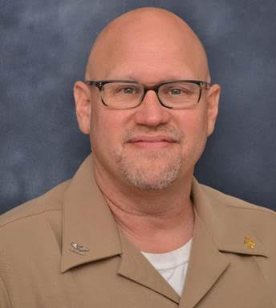
Dear Mycology Colleagues,
Please join me in congratulating Tom Chiller, MD, MPHTM, (Captain USPHS) who has recently been appointed to the position of Branch Chief, Mycologic Disease Branch (MDB), for the CDC. Tom has been an important member of the scientific team in this division for 14 years. He has been deputy chief of MDB since 2007, and acting branch chief since this January. He also served as the associate director for epidemiologic science for the division from 2007-2015. Tom will continue to supervise the Global Health Unit as associate director of global programs.
Tom has been an active member of the MSG for over a decade, and has been instrumental in several key collaborations between MSG and CDC, most recently the multinational retrospective survey of cryptococcosis (MSG 07) and the long term follow up study of patients involved in the fungal meningitis outbreak of 2012-13 (MSG 08). Tom was also critical in the development of OTIP, a prospective cohort study of high-risk transplant recipients which followed the completion of TRANSNET. Tom’s main clinical interests are in the early diagnosis, epidemiology, early treatment and prevention of fungal infections.
Tom is a great friend of mycology both within and outside of the MSG. Through his ongoing involvement in CDC’s global programs and in his new role as Branch Chief, Tom’s influence in truly worldwide. I am very grateful for our friendship and the close working relationship we have developed over the years. I look forward to working even closer with Tom and our colleagues at CDC in the coming years.
I would also like to thank Mary Brandt, PhD, who has been a tremendous collaborator, friend, and supporter of the MSG. She has been a skilled leader of the Mycology Branch and maintained good working relationship with MSG and many of our investigators over the years. She also helped to facilitate several of our studies and played a key role in the development of specimen repositories at CDC for TRANSNET, OTIP, and several ongoing MSG studies. You will be missed, Mary, and thanks for your devoted service.
Peter
Peter G. Pappas, MD, FACP
William E. Dismukes Professor of Medicine
Principal Investigator, Mycoses Study Group
Division of Infectious Diseases
University of Alabama at Birmingham
1900 University Blvd
229 THT
Birmingham, AL 35294-0006
205-934-9951 (phone)
205-934-5155 (fax)

